Introduction to Computer Architecture

A computer is *any device* that processes data.

## Three Box Model

|  |  |  |  |  |
| --- | --- | --- | --- | --- |
| Input | 🡺 | Process | 🡺 | Output |

# The Processor

* Each processor has **instruction sets** that define how to instruct it to perform tasks.
* Tiny wires called **buses** connect groups of transistors and other components.
* The **system clock** times pulses in the computer.

# Memory

* **Volatile memory** is storage that requires power to hold data (e.g. RAM).
* **Main Memory (RAM / Random Access Memory)** stores the running state of the computer; it is volatile.
* **ROM (Read Only Memory)** is storage that cannot be written onto; it is non-volatile; used for the BIOS.

# The System Bus

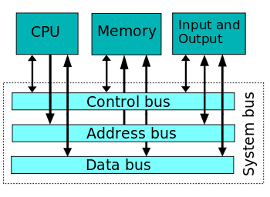

**Example cycle – retrieving data:**

* CPU sends a memory address to main memory through the *address bus*.
* CPU sends a signal in to specify that it’s reading rather than writing, on the *control bus*.
* Memory sends requested data to the CPU via the *data bus*.